Week 4: Advanced SOC Operations – Threat Hunting, Automation, and Incident Analysis
Kanchi kakkad
SOC task-4
Cyart
23//1/26

Theoretical Knowledge

1. Threat Hunting Methodologies
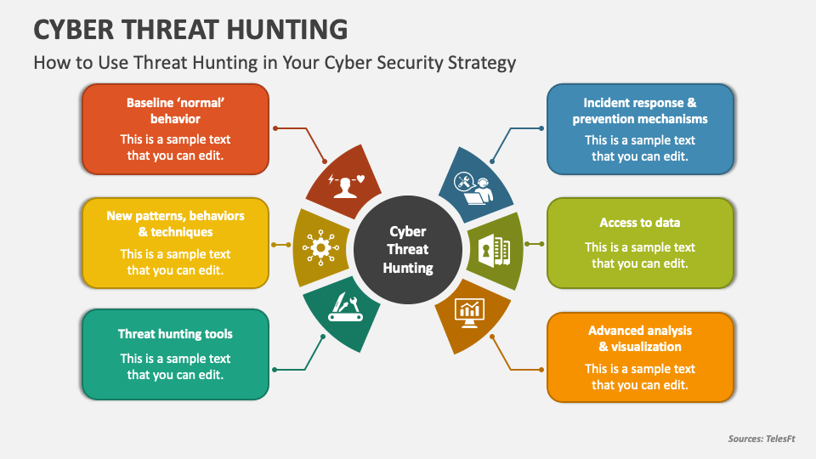

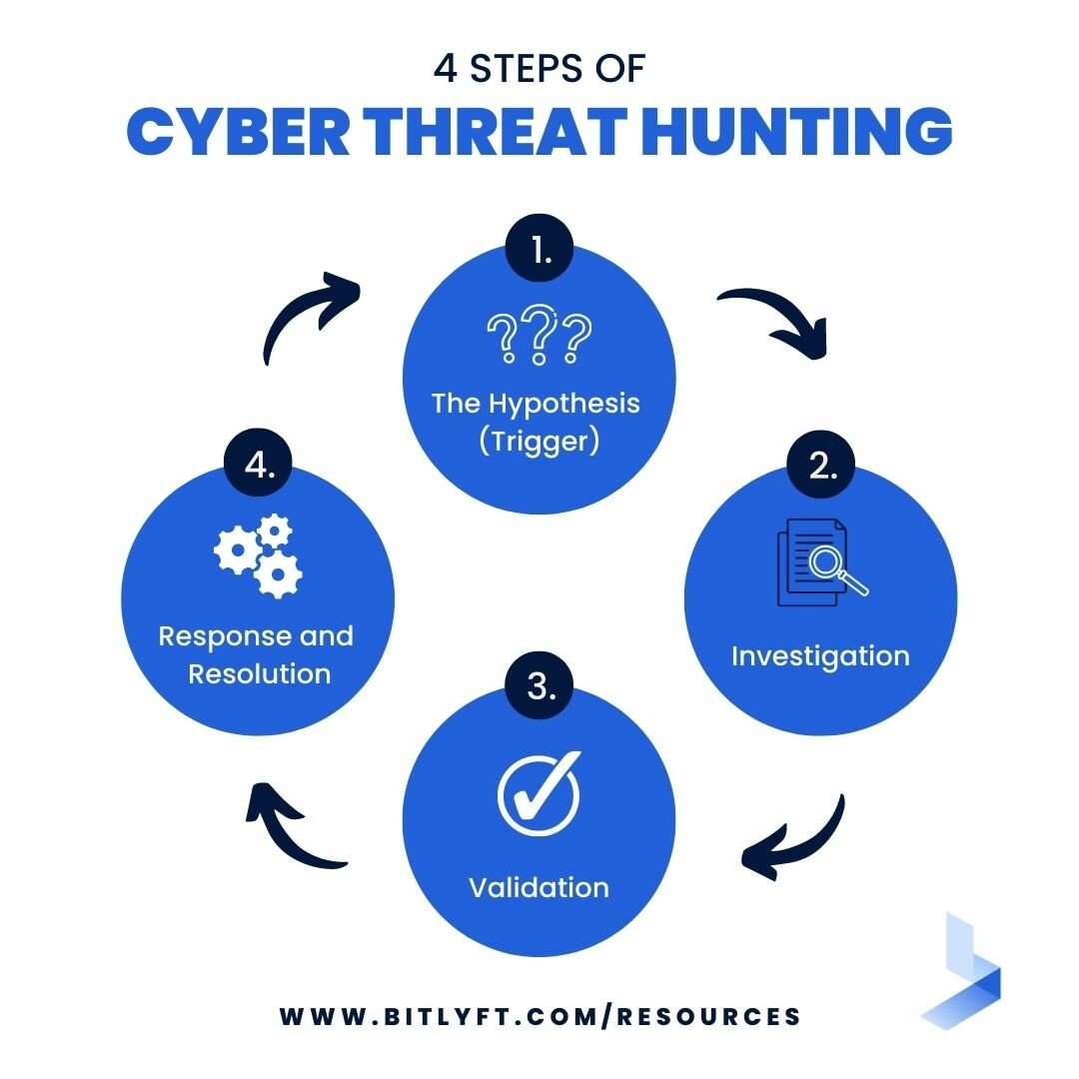

Threat hunting is a proactive security activity where SOC analysts actively search for threats that may not be detected by automated tools. Instead of waiting for alerts, analysts begin with a hypothesis, such as possible misuse of valid user accounts or abnormal privilege escalation, and then investigate system logs and telemetry to verify whether such activity exists. This approach is especially useful for identifying advanced or stealthy attacks that can bypass traditional detection mechanisms.
To conduct threat hunting in a structured manner, frameworks such as SqRR (Search, Query, Retrieve, Respond) and TaHiTI (Targeted Hunting integrating Threat Intelligence) are commonly used. These frameworks guide analysts through defining the hunt objective, selecting relevant data sources, and responding to any findings. Using such methodologies helps ensure that threat hunting is consistent, repeatable, and effective across different scenarios.
Threat hunting relies on analyzing data from multiple sources, including endpoint logs, authentication records, network traffic, and threat intelligence feeds. By correlating data from these sources, analysts can identify suspicious patterns that may not be visible in isolation. As a result, threat hunting plays a crucial role in strengthening an organization’s overall security posture.

2. Advanced SOAR Automation
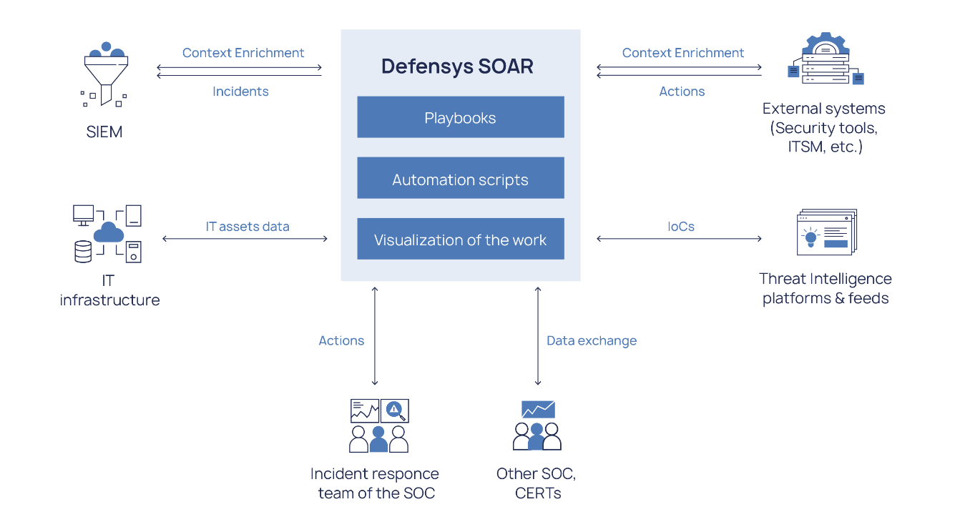

Security Orchestration, Automation, and Response (SOAR) platforms are designed to help SOC teams handle large volumes of alerts more efficiently. Orchestration allows different security tools to work together, automation reduces the need for manual intervention, and response enables quick containment of threats. Together, these capabilities significantly improve response time and reduce analyst workload.
A key component of SOAR platforms is the use of playbooks, which define step-by-step actions for handling specific types of incidents. For example, a phishing response playbook may automatically check the reputation of a suspicious IP address, block it if found malicious, and create an incident ticket for tracking. Automating these routine actions ensures consistency and reduces the chance of human error.
SOAR platforms are often integrated with SIEM and EDR tools so that alerts can automatically trigger predefined response workflows. This integration allows SOC teams to move quickly from detection to response, making automation an essential element of modern security operations.

3. Post-Incident Analysis and Continuous Improvement
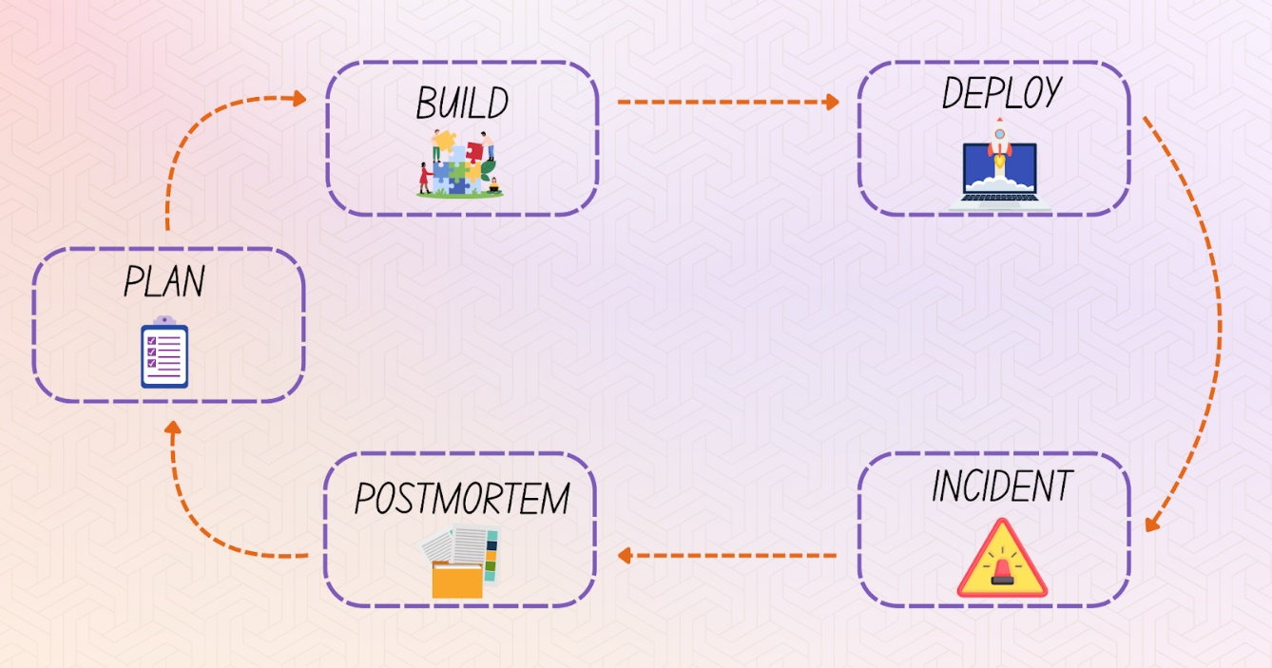

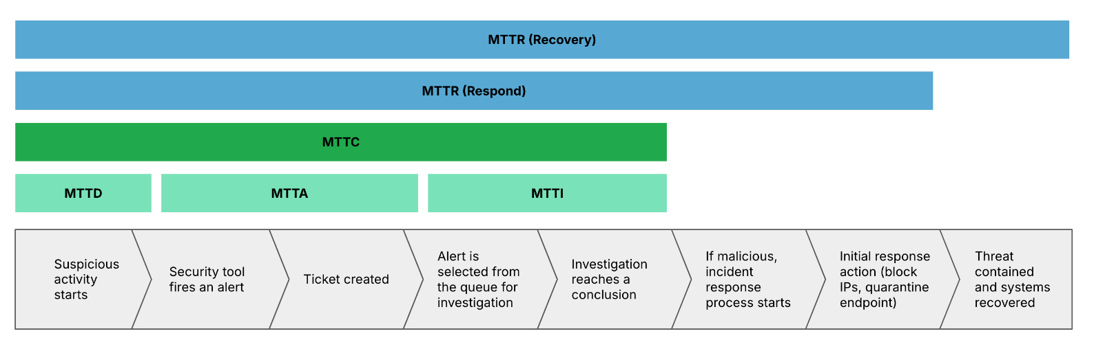
Post-incident analysis focuses on understanding what happened after a security incident has been resolved. Instead of stopping at containment and recovery, SOC teams review incidents to identify weaknesses in detection, response, or processes. Root Cause Analysis techniques such as the 5 Whys or Fishbone diagrams help analysts uncover the underlying reasons behind an incident.
Lessons learned from post-incident reviews are used to improve SOC operations. These may include updating detection rules, improving response playbooks, or providing additional training to analysts. This continuous feedback loop ensures that the SOC becomes more effective over time and better prepared for future incidents.
Security metrics play an important role in post-incident evaluation. Metrics such as Mean Time to Detect (MTTD) and Mean Time to Respond (MTTR) help measure how quickly incidents are identified and handled. Monitoring these metrics allows SOC teams to track performance improvements and identify areas that require attention.

4. Adversary Emulation Techniques

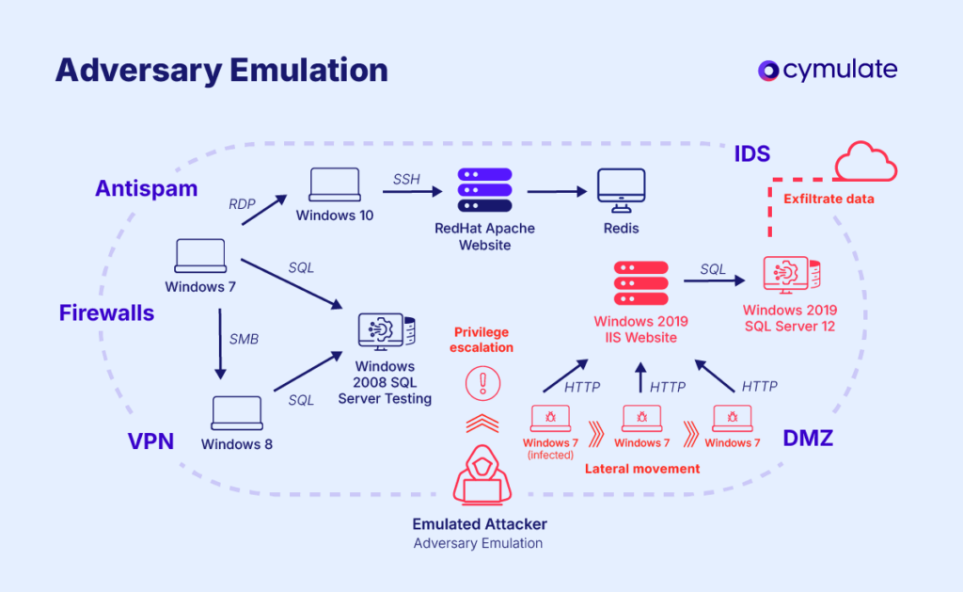

Adversary emulation involves simulating real-world attacker behavior to test how well security controls and detection systems perform. Instead of relying only on theoretical threats, SOC teams use known attacker techniques to assess whether existing defenses can detect and respond to attacks effectively.
The MITRE ATT&CK framework provides a detailed mapping of attacker tactics and techniques, while tools such as MITRE Caldera enable automated execution of these techniques in a controlled environment. For example, simulating phishing attacks or exploitation of remote services allows SOC teams to observe detection behavior and identify any gaps.
Adversary emulation also encourages collaboration between offensive and defensive teams. While red teams simulate attacks, blue teams focus on detection and response. Insights gained from these exercises help improve detection rules, response workflows, and overall SOC readiness.

5. Security Metrics and Executive Reporting
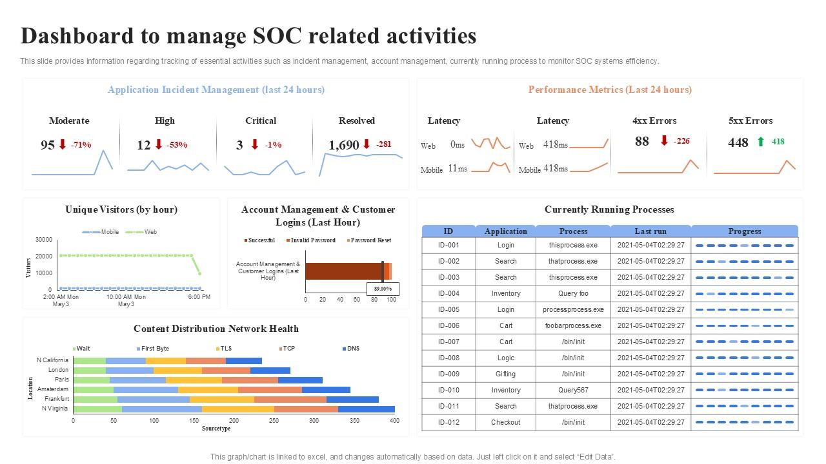

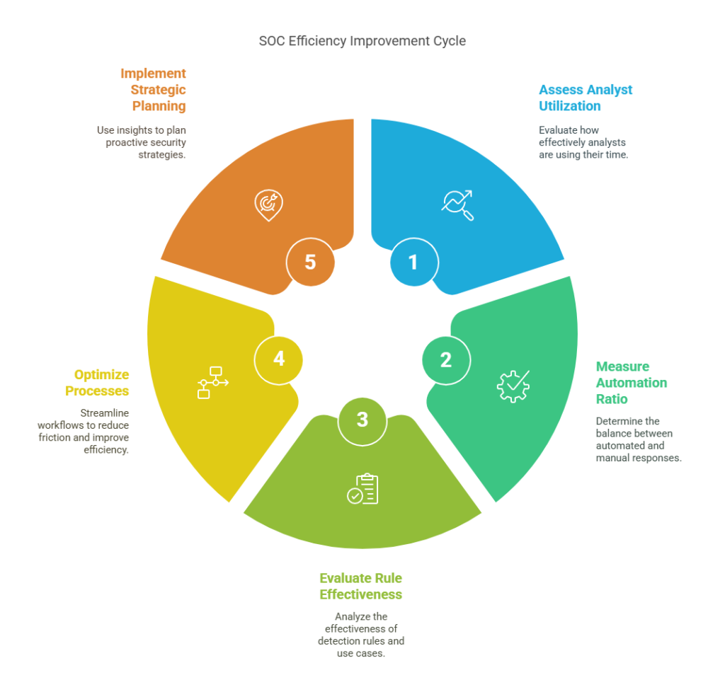
Security metrics are used to measure the effectiveness of SOC operations and guide decision-making. Advanced metrics such as dwell time, false positive rate, and incident resolution rate provide valuable insights into how well threats are detected and handled. These metrics help SOC teams identify operational strengths and weaknesses.
Executive reporting focuses on presenting security information in a clear and understandable manner for non-technical stakeholders. Instead of technical logs or alerts, SOC teams use dashboards, charts, and concise summaries to explain risks, trends, and incident impact. This enables leadership to make informed decisions regarding security strategy and resource allocation.
By continuously reviewing security metrics and reporting outcomes, organizations can drive improvements in detection capabilities, response efficiency, and overall security posture.

Practical task

Task 1: Threat Hunting and Initial Detection

1.1 Environment Setup
The monitoring environment consisted of two Ubuntu virtual machines. VM1 was configured with the Wazuh Manager and Splunk Enterprise, acting as the central monitoring and analysis system. VM2 was configured with the Wazuh Agent and served as the monitored endpoint. SSH services were enabled on VM2 to generate authentication-related events for analysis.
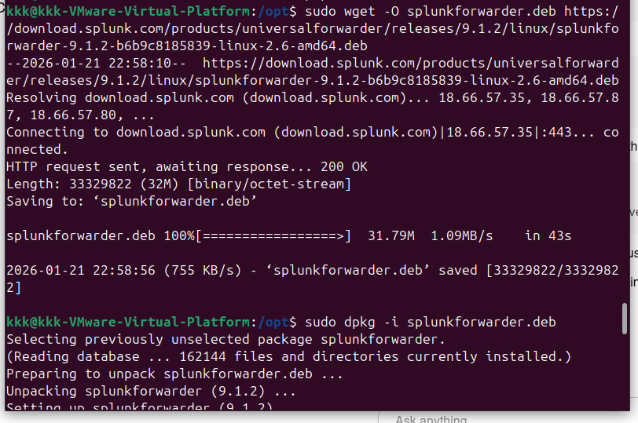

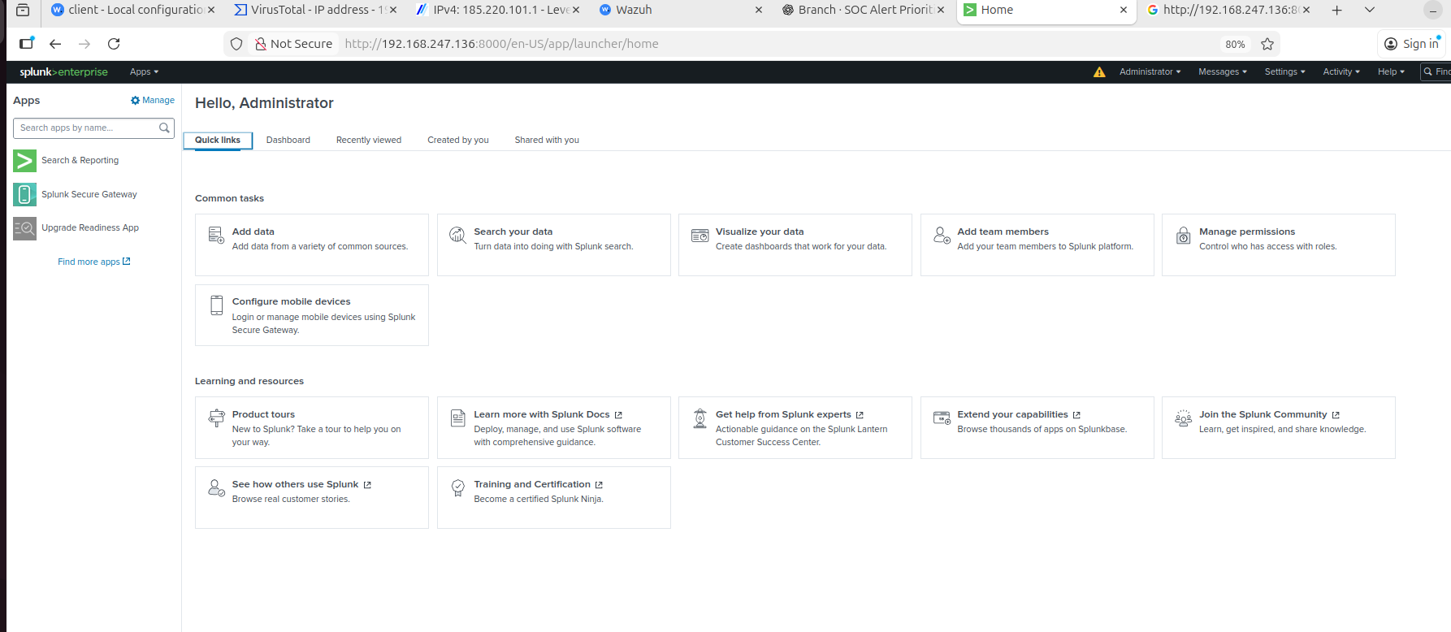

1.2 Activity Generation (Attack Simulation)
To simulate suspicious activity, multiple failed SSH login attempts were intentionally generated on the monitored endpoint (VM2). Incorrect credentials were repeatedly used to access the SSH service. This activity produced authentication failure events within the system authentication log file (/var/log/auth.log). These logs represent a common attack pattern associated with brute-force attempts against SSH services.
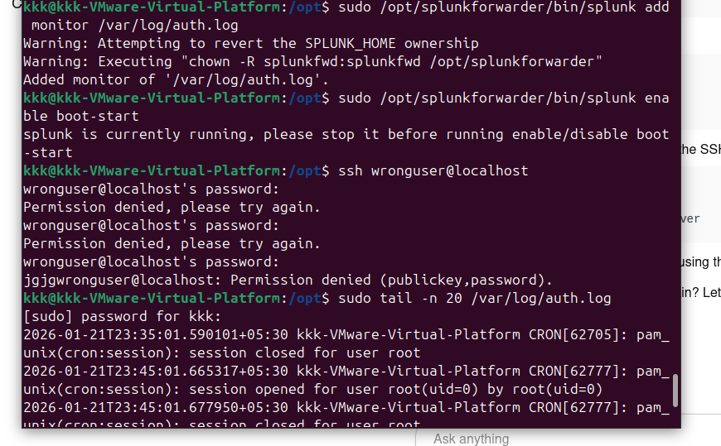

1.3 Detection Using Wazuh
The Wazuh Agent on VM2 collected the authentication logs and forwarded them to the Wazuh Manager on VM1. Wazuh successfully detected repeated SSH authentication failures and generated security alerts. The alert was triggered under Rule ID 2502, which identifies multiple failed password attempts. The event was mapped to the MITRE ATT&CK framework under technique T1110 (Brute Force), indicating potential credential access attempts.
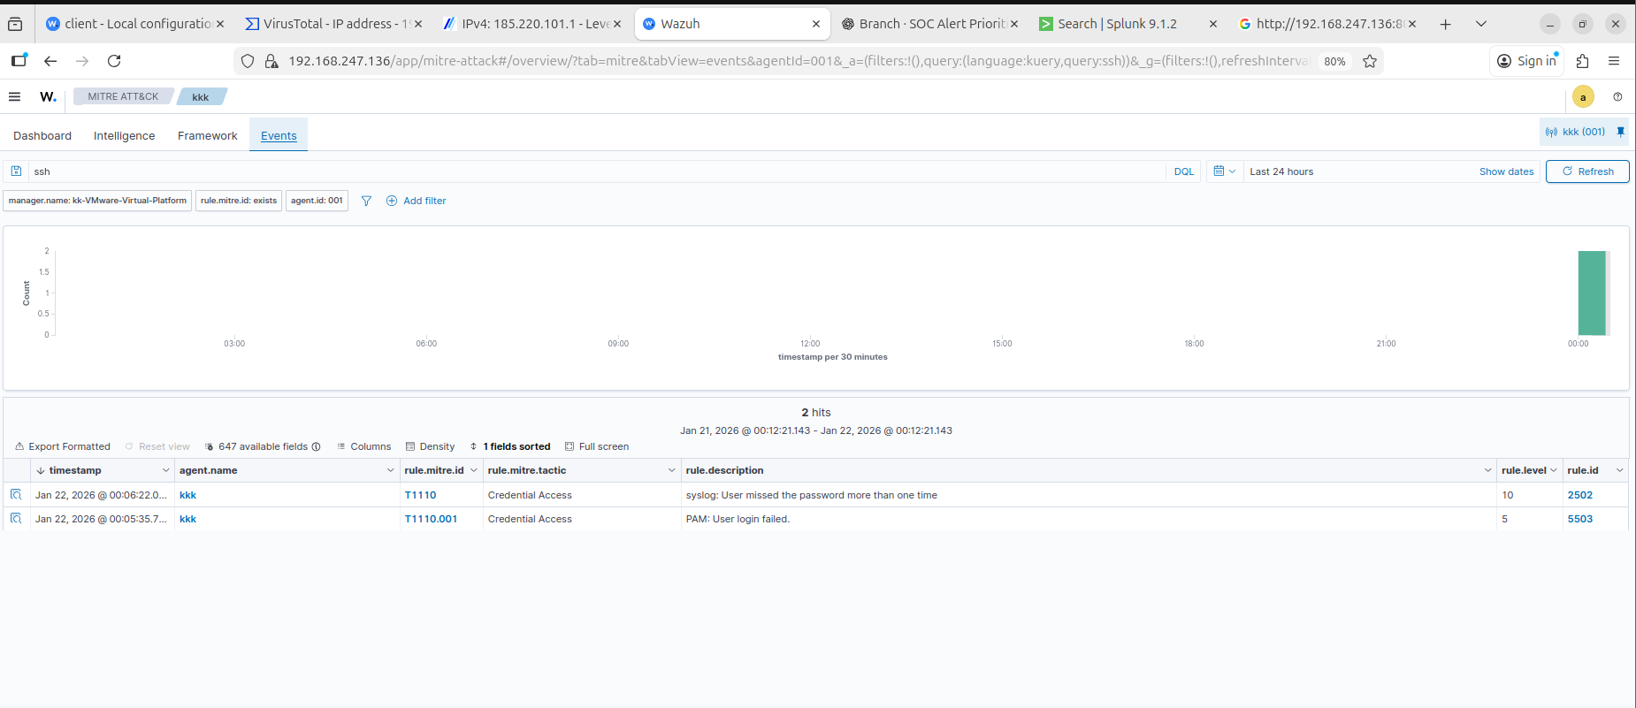

1.4 Threat Hunting Using Splunk
In addition to automated detection, manual threat hunting was performed using Splunk Enterprise on VM1. Linux authentication logs were ingested into Splunk, and search queries were executed to identify SSH-related failures. Queries targeting failed password attempts were used to locate repeated authentication failures within a short time window. This manual analysis helped validate the alerts generated by Wazuh and provided deeper visibility into the attack pattern.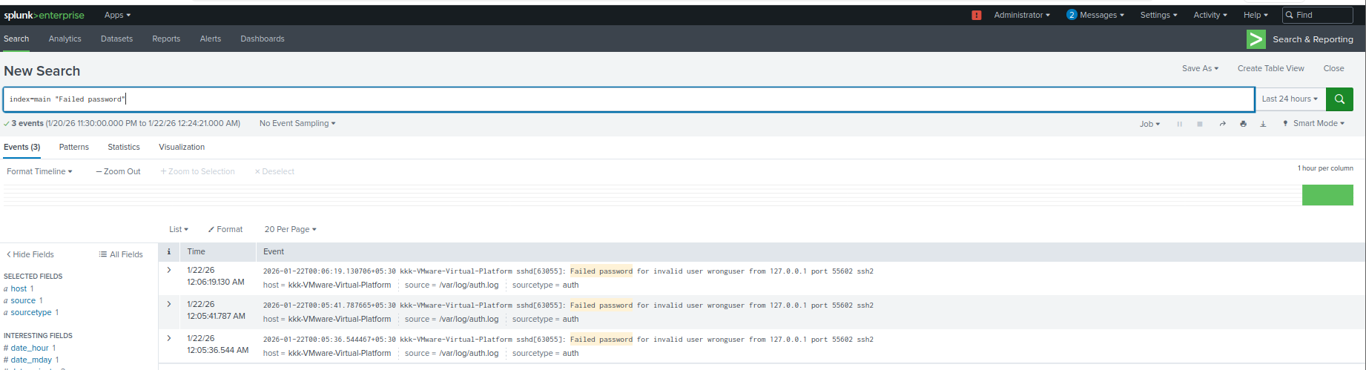

1.5 Analysis and Findings
The analysis confirmed multiple failed SSH authentication attempts originating from the local system. Although no successful login or privilege escalation was observed, the repeated failures matched known brute-force behavior. The incident was classified as a true positive security event with medium severity, as it demonstrated a realistic attack pattern without resulting in system compromise.

Task 2: Alert Triage, Incident Ticket Creation, and IOC Validation

2.1 Alert Triage and Analysis
Following the detection of repeated SSH authentication failures in Task 1, the alert was reviewed in the Wazuh dashboard. The alert was generated under Rule ID 2502, indicating multiple failed password attempts within a short time interval. The alert details, including the affected host, timestamps, and log source, were examined to determine whether the activity represented a true security concern or a false positive.
Based on the frequency of failed authentication attempts and the associated rule severity, the alert was classified as a true positive event. Although no successful login was observed, the behavior matched known brute-force attack patterns targeting SSH services.

2.2 Incident Ticket Creation
After confirming the alert as a true positive, a formal incident ticket was created to document and track the security event. The incident ticket included essential details such as incident title, severity level, affected asset, detection source, and MITRE ATT&CK mapping. Creating an incident ticket ensured traceability, accountability, and structured handling of the event throughout its lifecycle.
The incident was assigned a medium severity, as the activity demonstrated malicious behavior without resulting in system compromise. 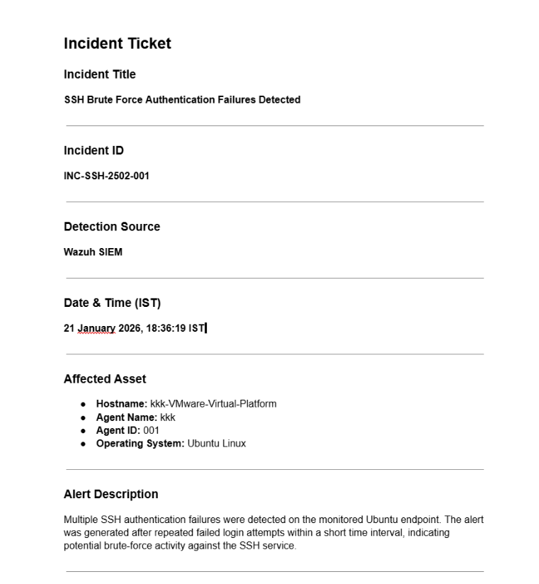

2.3 Indicator of Compromise (IOC) Identification and Validation
Relevant indicators of compromise were extracted from the alert, including the source IP address and the targeted service. The source IP address (127.0.0.1) was analyzed using external threat intelligence platforms such as VirusTotal and AlienVault OTX. The investigation confirmed that the IP address did not have a malicious reputation and was internal to the system.
Despite the absence of malicious intelligence indicators, the repeated authentication failures were still treated as suspicious due to their behavioral pattern. This step highlighted the importance of combining threat intelligence with analyst judgment during alert triage.
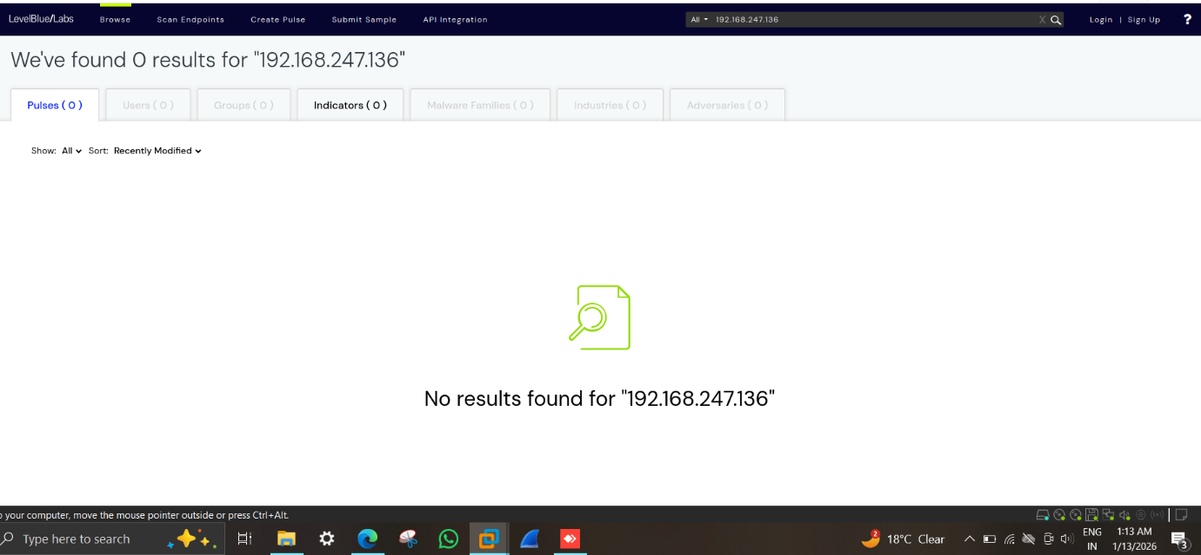

Task 3: Post-Incident Analysis and Lessons Learned

3.1 Incident Reference
This post-incident analysis is conducted based on the incident ticket created during Task 2 for repeated SSH authentication failures detected on an Ubuntu endpoint. The incident was identified by Wazuh SIEM under Rule ID 2502 and classified as a potential SSH brute-force attempt. The source IP address was identified as localhost (127.0.0.1), and the incident was assessed and closed with monitoring recommendations.

3.2 Incident Summary
The incident involved multiple failed SSH login attempts within a short time interval on the monitored system. The activity triggered a security alert in Wazuh indicating repeated authentication failures. Although the source IP was internal, the behavior matched known brute-force patterns and was therefore treated as a true positive security event for analysis and documentation purposes.

3.3 Root Cause Analysis (5 Whys)
A structured Root Cause Analysis was performed using the 5 Whys methodology to identify the underlying cause of the incident.
- Why was the alert generated?
Because multiple SSH authentication failures were detected in a short time frame.
- Why did authentication failures occur?
Incorrect credentials were repeatedly entered for SSH access.
- Why were repeated attempts allowed?
The SSH service did not enforce account lockout or rate-limiting.
- Why was rate-limiting not enforced?
Default SSH security configurations were in place without additional hardening.
- Root Cause Identified:
Lack of SSH brute-force protection mechanisms such as rate-limiting or automatic blocking.

3.4 Detection and Response Evaluation
The detection mechanism functioned effectively during this incident. Wazuh successfully identified abnormal SSH authentication behavior and generated a timely alert. The incident was promptly reviewed by the analyst, converted into a formal incident ticket, and enriched with threat intelligence validation. The response workflow ensured proper documentation and traceability throughout the incident lifecycle.

3.5 What Worked Well
- Wazuh accurately detected repeated SSH authentication failures.
- The alert was correctly mapped to MITRE ATT&CK technique T1110 (Brute Force).
- Incident ticket creation ensured structured handling and accountability.
- Threat intelligence validation prevented unnecessary escalation.
- Analyst assessment correctly classified the incident severity.

3.6 Identified Gaps
The post-incident review highlighted the following gaps:
- SSH allowed multiple authentication attempts without restriction.
- No automated preventive control (such as IP blocking) was triggered.
- Security controls were more reactive than preventive.

3.7 Lessons Learned
The incident demonstrated that while detection capabilities were effective, preventive controls were insufficient. Repeated authentication failures can be reduced by implementing stronger SSH hardening measures. The incident also reinforced the importance of structured incident documentation and post-incident review in improving SOC operations.

3.8 Recommendations
Based on the findings, the following recommendations are proposed:
- Enable SSH key-based authentication and disable password-based logins where feasible.
- Implement brute-force prevention mechanisms such as fail2ban.
- Configure alert thresholds to trigger early warnings.
- Conduct periodic reviews of authentication logs.
- Apply security hardening guidelines for critical services.

3.9 Incident Metrics
The following metrics were estimated based on the incident timeline:
- Mean Time to Detect (MTTD): ~5 minutes
- Mean Time to Respond (MTTR): ~15 minutes
- Incident Severity: Medium
- Incident Impact: Low

3.10 Post-Incident Conclusion
The SSH brute-force incident was effectively detected, analyzed, and documented using Wazuh and structured SOC processes. Although no external compromise occurred, the incident exposed configuration-level weaknesses that require improvement. Implementing the recommended controls will strengthen the system’s security posture and reduce the likelihood of similar incidents in the future.

Task 4: Evidence Preservation and Chain of Custody

4.1 Evidence Identification
The primary evidence identified for this incident was the Linux authentication log file (/var/log/auth.log) generated on the monitored Ubuntu endpoint. This file contains records of SSH authentication failures relevant to the incident.
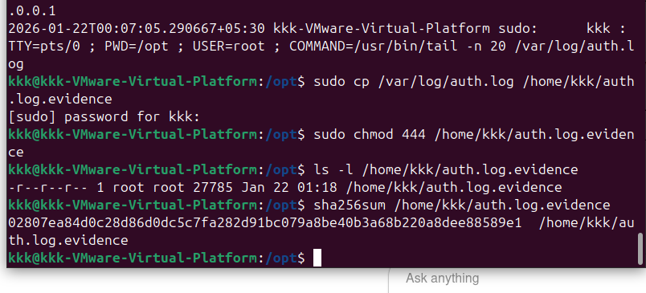

4.2 Evidence Collection and Integrity
A forensic copy of the authentication log file was created and stored securely. File permissions were restricted to read-only to prevent modification. A SHA-256 cryptographic hash was generated to verify the integrity of the preserved evidence.

4.3 Chain of Custody
A chain of custody record was maintained to document the collection, handling, and storage of the evidence. This ensured accountability and confirmed that the evidence remained unaltered throughout the process.

Chain of Custody Record
Field | Details
Evidence ID | EVD-SSH-LOG-001
Evidence Type | Authentication Log File
Original File Name | /var/log/auth.log
Evidence File Name | auth.log.evidence
Source System | Ubuntu Linux VM (Wazuh Agent – VM2)
File Location (Stored) | /home/kkk/auth.log.evidence
Description of Evidence | SSH authentication logs containing multiple failed login attempts and sudo activity related to brute-force authentication events
Date & Time Collected | 22 January 2026, 01:18 IST
Collected By | SOC Analyst (kkk)
Method of Collection | Secure file copy using cp command
Preservation Action | File permissions set to read-only (chmod 444) to prevent modification
File Owner | root
File Permissions | -r--r--r--
Hash Algorithm | SHA-256
Hash Value | 02807ea84d0c28d86d0dc5c7fa282d91bc079a8be40b3a68b220a8dee88589e1
Verification Status | Hash successfully generated and verified
Chain of Custody Status | Maintained – No unauthorized access or modification detected
Remarks | Evidence preserved following forensic best practices for integrity and admissibility

The authentication log file (auth.log) was collected from the affected Ubuntu endpoint to preserve evidence related to SSH authentication failures. The file was securely copied to a controlled location and marked as read-only to ensure integrity. A SHA-256 cryptographic hash was generated to verify that the evidence remained unaltered. This process ensures proper chain of custody and forensic soundness of the collected evidence.

Task 5: Incident Escalation and Analyst Documentation

Incident Escalation
After alert triage and validation, the SSH brute-force incident was confirmed as a true positive. Although no successful compromise was observed, the repeated authentication failures warranted escalation for monitoring and awareness. The incident was escalated from Tier 1 to Tier 2 for informational purposes.

Escalation Summary (SITREP)
A Situation Report (SITREP) was prepared to summarize the incident, including detection details, severity level, affected system, actions taken, and recommended next steps. The escalation documentation ensured clarity, traceability, and consistent communication within the SOC.

Escalation Summary (SITREP)
Incident Title:
SSH Brute Force Authentication Failure
Incident ID:
ALRT-SSH-001
Detection Source:
Wazuh SIEM
Date and Time Detected:
22 January 2026, 01:18 IST
Affected Asset:
Ubuntu Linux Endpoint (Wazuh Agent – VM2)
Severity Level:
Medium
MITRE ATT&CK Mapping:
T1110 – Brute Force (Credential Access)

Incident Overview
Multiple SSH authentication failures were detected on an Ubuntu endpoint within a short time interval. The activity triggered Wazuh rule ID 2502, indicating repeated failed login attempts. Log analysis confirmed the presence of PAM authentication failure events generated by the SSH daemon.

Source and Impact Analysis
The source IP address associated with the activity was identified as 127.0.0.1, indicating that the failed authentication attempts originated from the local system. No successful login attempts, privilege escalation, or lateral movement were observed. Based on the analysis, the incident did not result in system compromise or data exposure.

Actions Taken
- Alert was triaged and confirmed as a true positive
- Authentication logs were collected and preserved as forensic evidence
- SHA-256 hash of the log file was generated to maintain evidence integrity
- Incident details were documented for traceability
- Incident was escalated for awareness and continued monitoring

Current Status
Contained – Monitoring

Recommendations
- Continue monitoring SSH authentication activity
- Review local user authentication configurations
- Implement account lockout and brute-force protection mechanisms
- Enable additional SSH logging for improved visibility

Escalation Decision
The incident was escalated from Tier 1 to Tier 2 for informational purposes and monitoring. No immediate containment or remediation actions were required due to the absence of successful compromise indicators.

Capstone Project

1. Introduction
This capstone project was carried out to understand how a Security Operations Center (SOC) handles a security incident from detection to response. The project involved simulating an attack on a vulnerable system, identifying the malicious activity, investigating it, and taking corrective actions. All tasks were performed in a controlled lab environment for learning purposes.

2. Lab Setup
The lab environment consisted of a Kali Linux virtual machine as the attacker and a Metasploitable2 virtual machine as the victim. The machines were connected through an isolated internal network. Monitoring and response were handled using tools such as Wazuh, TheHive, CrowdSec, and Elastic Security.

3. Reconnaissance and Enumeration
The first step was reconnaissance of the target system using Nmap from the Kali Linux machine. The scans revealed multiple open ports and services running on the Metasploitable2 system, including FTP, SSH, Telnet, SMB, HTTP, MySQL, and Tomcat. Several of these services were outdated and known to be vulnerable.
Screenshots show:
- Full port and service scan results
- Detection of vulnerable FTP service (vsftpd 2.3.4)
- SMB services exposed on ports 139 and 445
This confirmed that the target system had a large attack surface.

4. Vulnerability Identification
After scanning, vulnerability scripts were used to identify known issues. The FTP service running vsftpd 2.3.4 was found to be vulnerable to a backdoor exploit. SMB enumeration also revealed user and share information without proper authentication. These findings indicated that the system could be compromised easily.

5. Attack Simulation
An attack was simulated using Metasploit from the Kali Linux machine. The vsftpd 2.3.4 backdoor exploit module was selected and configured with the target IP address. After running the exploit, a shell session was successfully obtained on the victim machine with root privileges.
Screenshots show:
- Metasploit module selection
- Exploit configuration and execution
- Successful shell access on the target system
This demonstrated a successful exploitation of the vulnerable service.

6. Detection and Alerting
The malicious activity generated by the exploit was detected by the monitoring setup. Alerts related to suspicious behavior and exploitation attempts were generated and logged. These alerts were mapped to relevant attack techniques and indicated unauthorized access.

7. Incident Triage using TheHive
The detected incident was documented in TheHive by creating a new case. The case included details such as attack type, severity, attacker IP, and affected system. Tags related to Samba exploitation, Metasploit usage, and MITRE technique T1210 were added to the case for better classification.
Screenshot shows:
- TheHive case summary with severity, tags, and incident details

8. Response and Containment
As part of the response, the attacker IP address was blocked using CrowdSec to prevent further malicious activity. This action ensured that the compromised system was protected from repeated attacks. Connectivity checks confirmed that the attacker could no longer access the victim system.

9. Post-Incident Analysis
A basic root cause analysis was performed. The main reason for the incident was identified as the use of outdated and vulnerable services on the target machine. Lack of patching and insecure configurations contributed to the successful attack. 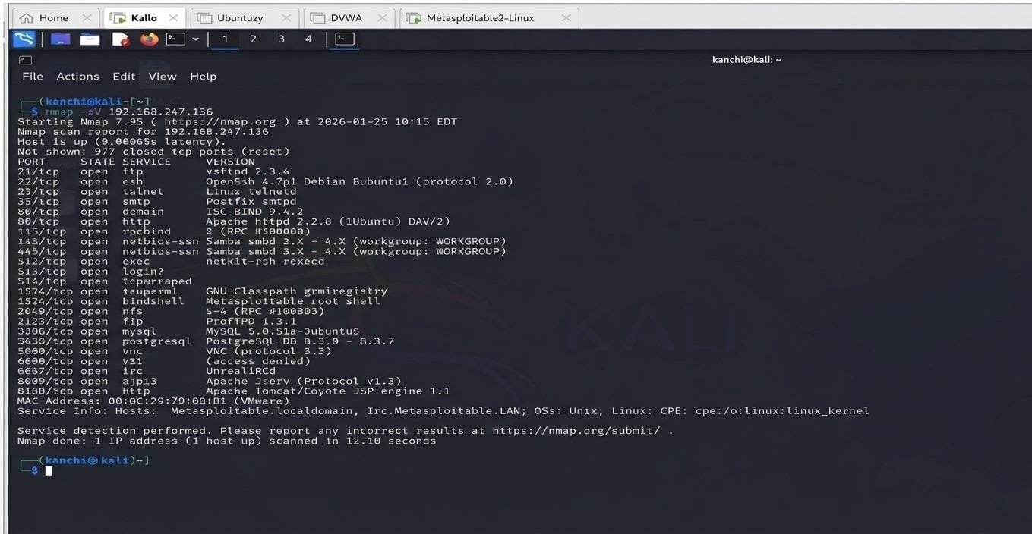
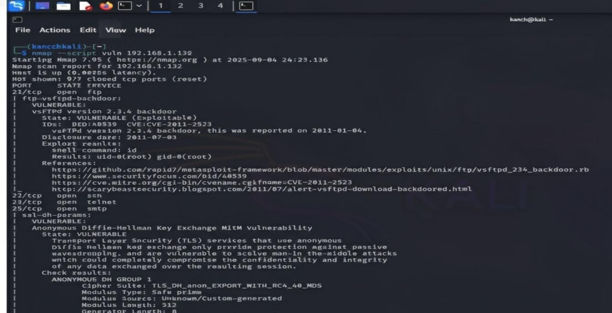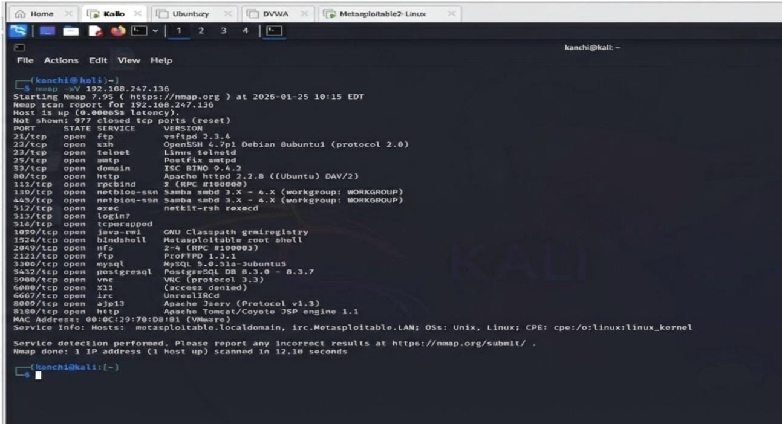
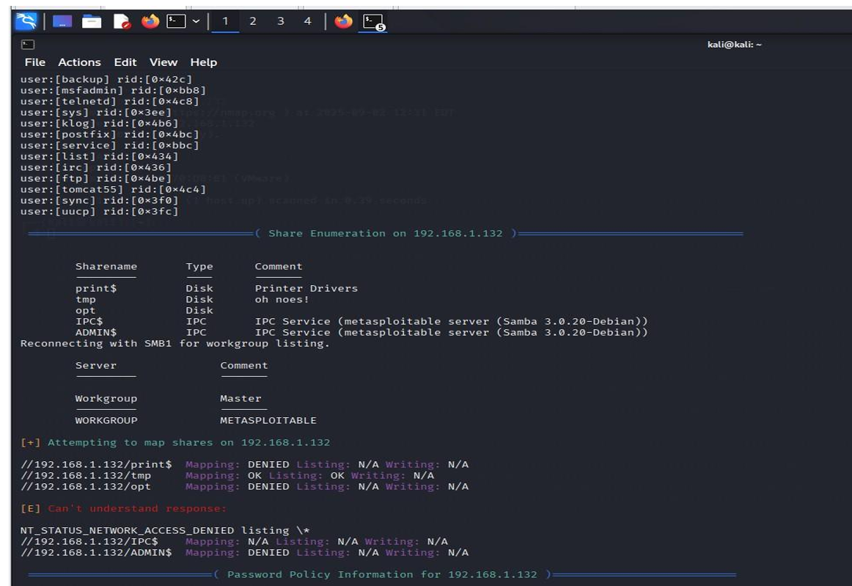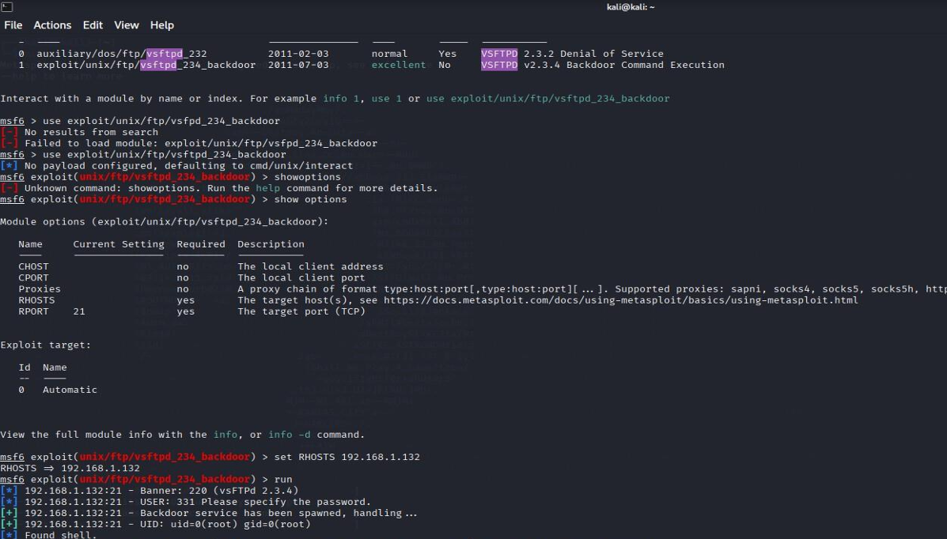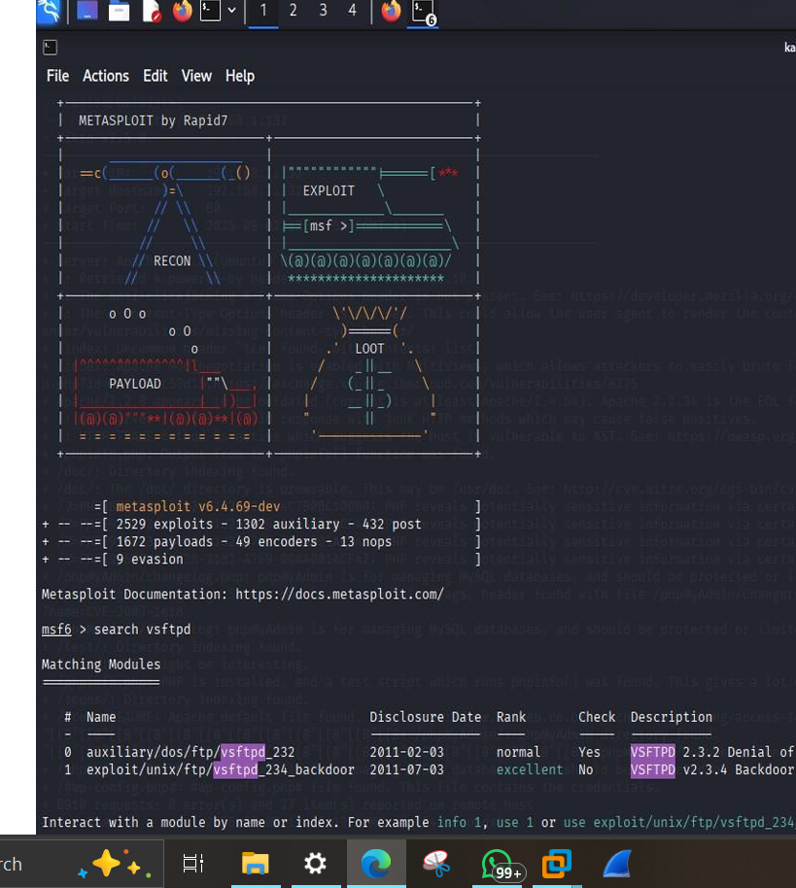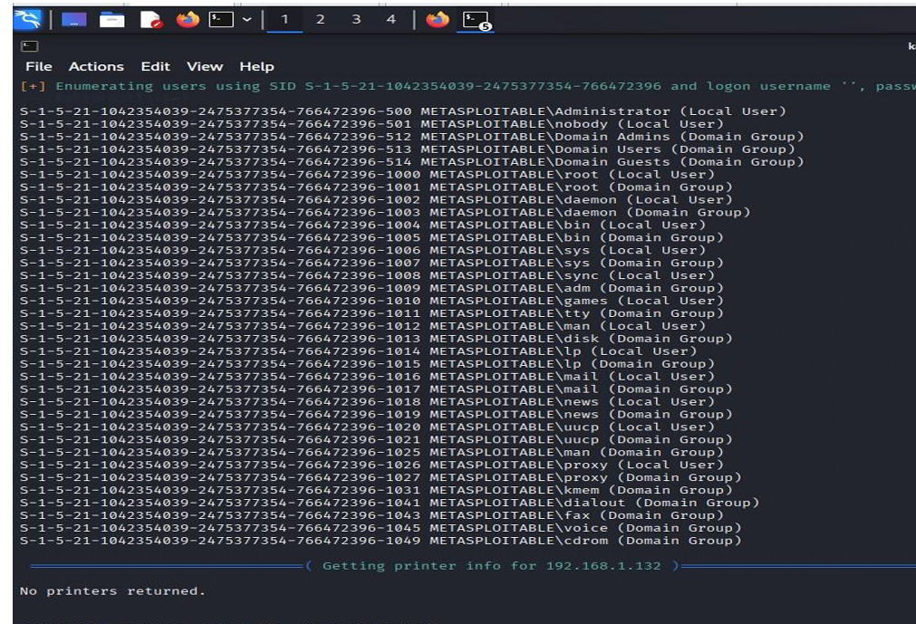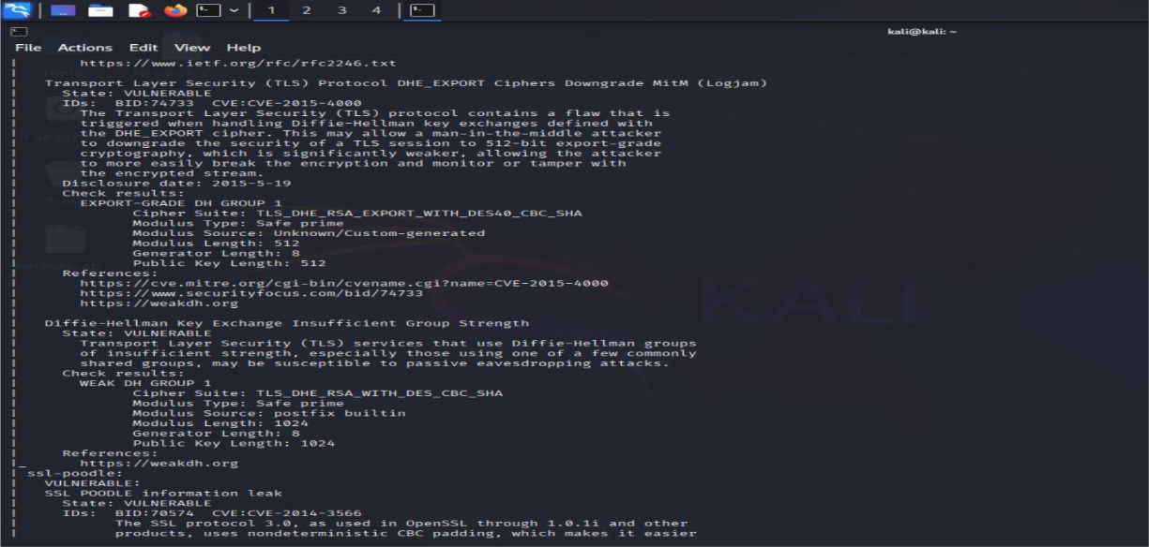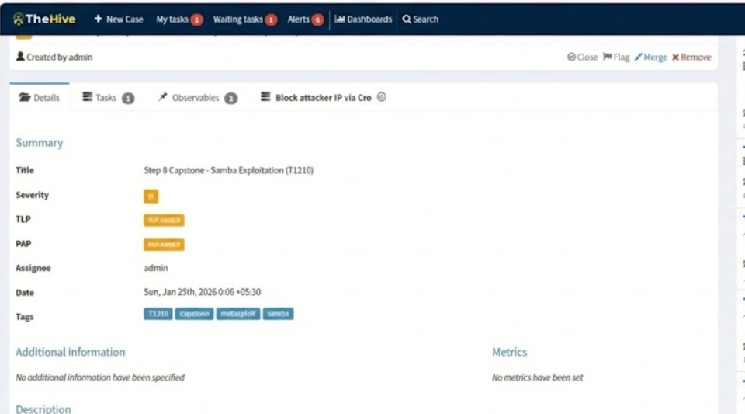

Conclusion
This assignment successfully demonstrated the complete Security Operations Center (SOC) incident handling lifecycle using a simulated SSH brute-force scenario. The process began with threat detection and log analysis, followed by alert triage, incident ticket creation, and threat intelligence validation. Proper evidence preservation and chain of custody procedures were applied to maintain forensic integrity. The incident was then escalated and documented through a structured escalation summary, and finally consolidated into a comprehensive incident report and management summary.
Overall, the tasks highlighted the importance of continuous monitoring, structured incident response, and clear documentation in effective SOC operations. The exercise reinforced practical skills in using SIEM tools, applying forensic best practices, and communicating security incidents in both technical and management-friendly formats.

